## Problem 3 – Contact Form

Create a Web form (HTML5 + CSS3 + images) that looks and behaves like the screenshots below:

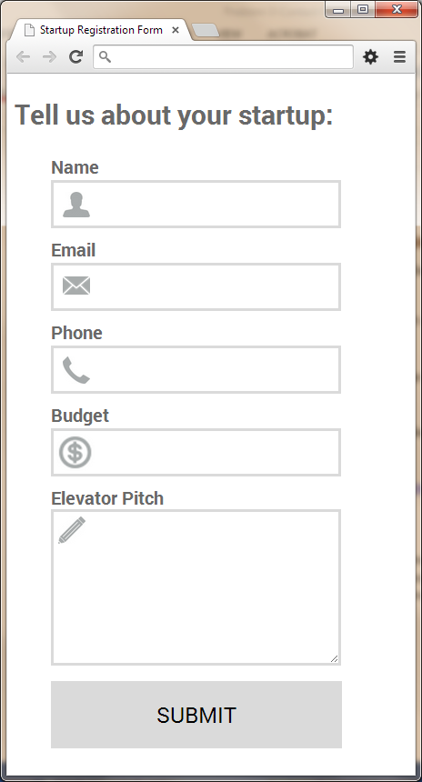 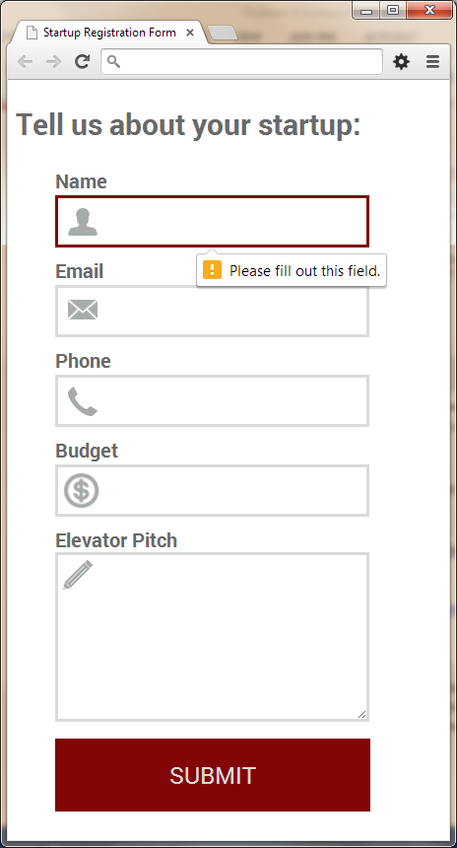

* The mouse hand-pointer is not part of your form, so please skip it. The button should be red both when hovered and focused.

### Input

You are given the above screenshots + the background image + the form field icons.

### Output

The output should be valid HTML5 + CSS3 + images that implement the above Web form.

### Constraints

* Fonts: <http://fonts.googleapis.com/css?family=PT+Sans:700>.
* Form width: 400px (fixed size).
* Form validation: all the fields must not be empty. The email field should contain a valid email address.
* The site should open correctly in Chrome 35.
* Responsive design is not required.
* Pixel-perfect implementation is not required.